# Jenkins - Management

To manage Jenkins, click on the "Manage Jenkins" option from the left hand of the Jenkins Dashboard page.

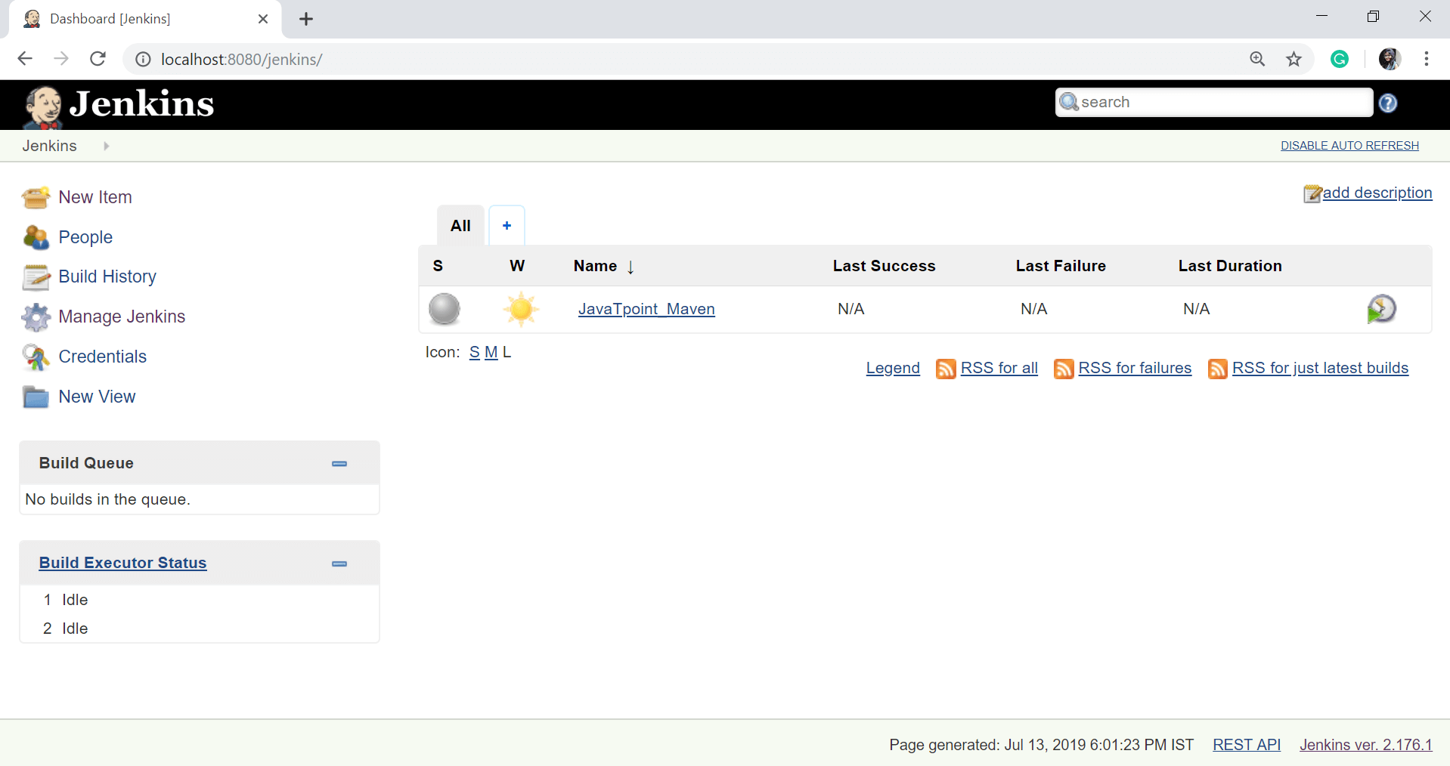

When you click on the Manage Jenkins, you will get the various options to manage the Jenkins:

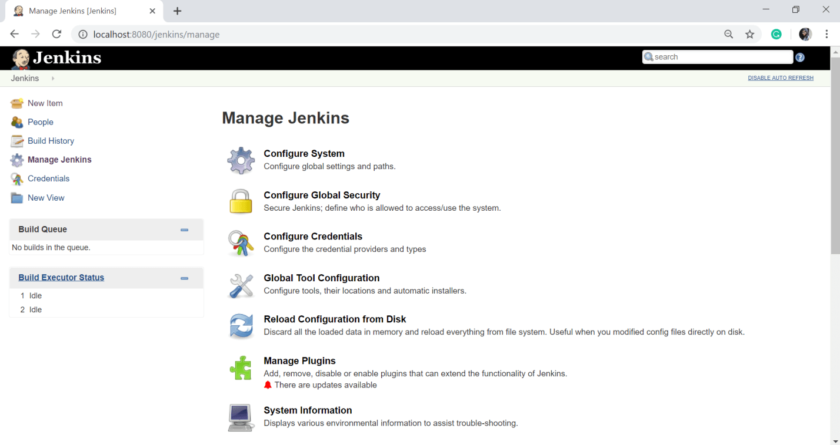  
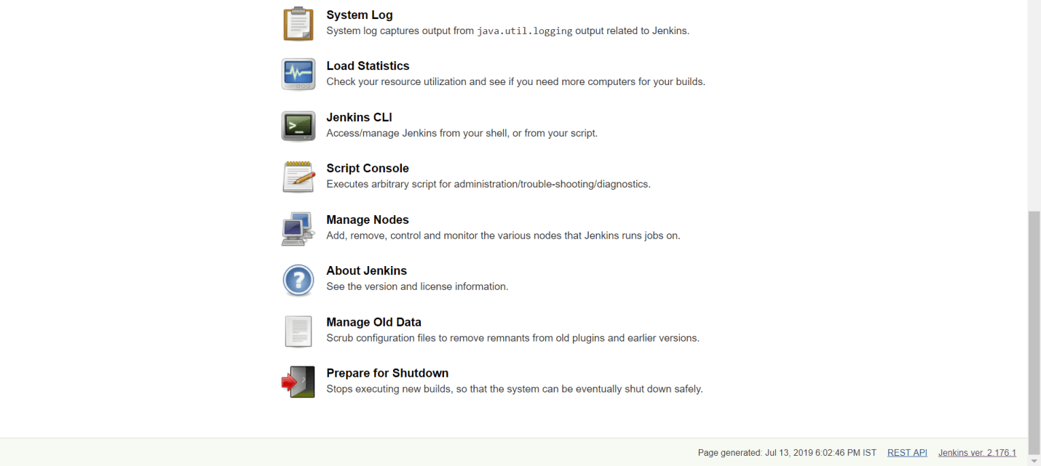

We have a lot of options in Jenkins Management page like:

* Configure System
* Configure Global Security
* Configure Credentials
* Global Tool Configuration
* Reload Configuration from Disk
* Manage Plugins
* System Information
* System Log
* Load Statistics
* Jenkins CLI
* Script Console
* Manage Nodes
* About Jenkins
* Manage Old Data and
* Prepare for Shutdown

Let's see some above management options:

### Configure System

In this, we can manage paths to the various tools to use in builds, such as the versions of Ant and Maven, as well as security options, email servers, and other system-wide configuration details. Jenkins will add the required configuration fields dynamically when new plugins are installed.

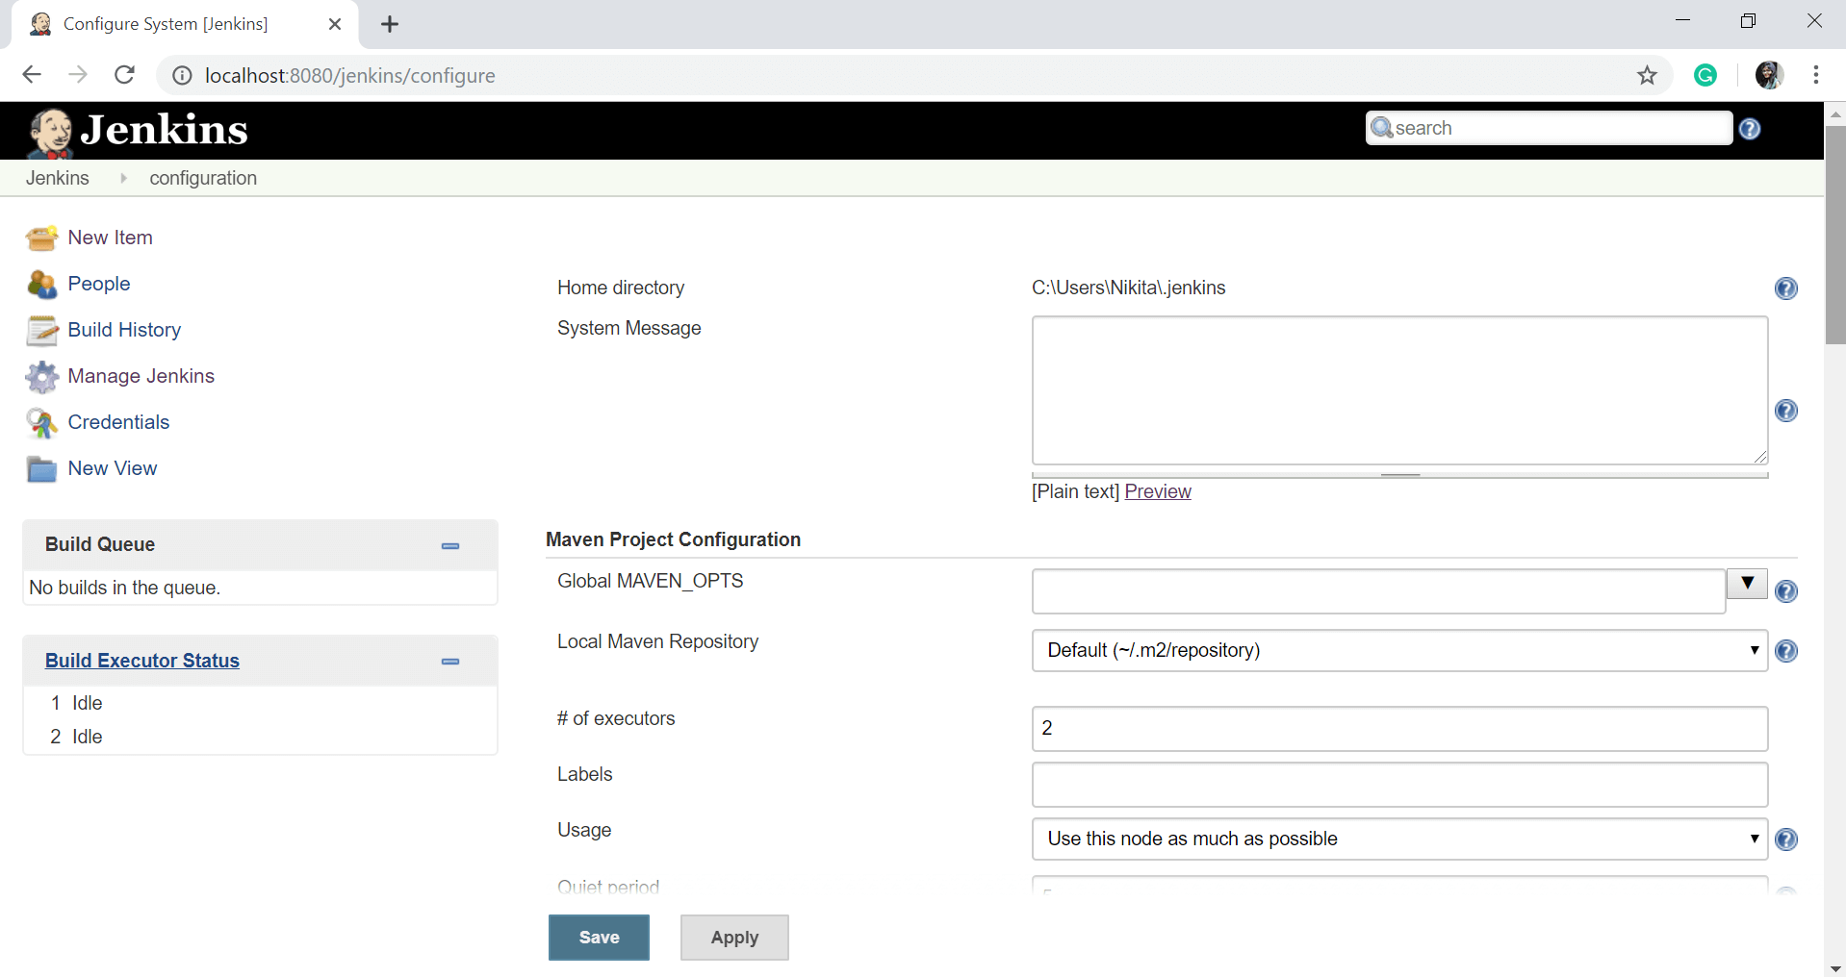

### Configure Global Security

Configure Global Security option provides the ability to set up users and their relevant permissions on the Jenkins instance. By default, you will not want everyone to be able to define builds or other administrative tasks in Jenkins. So Jenkins provides the ability to have a security configuration in place.

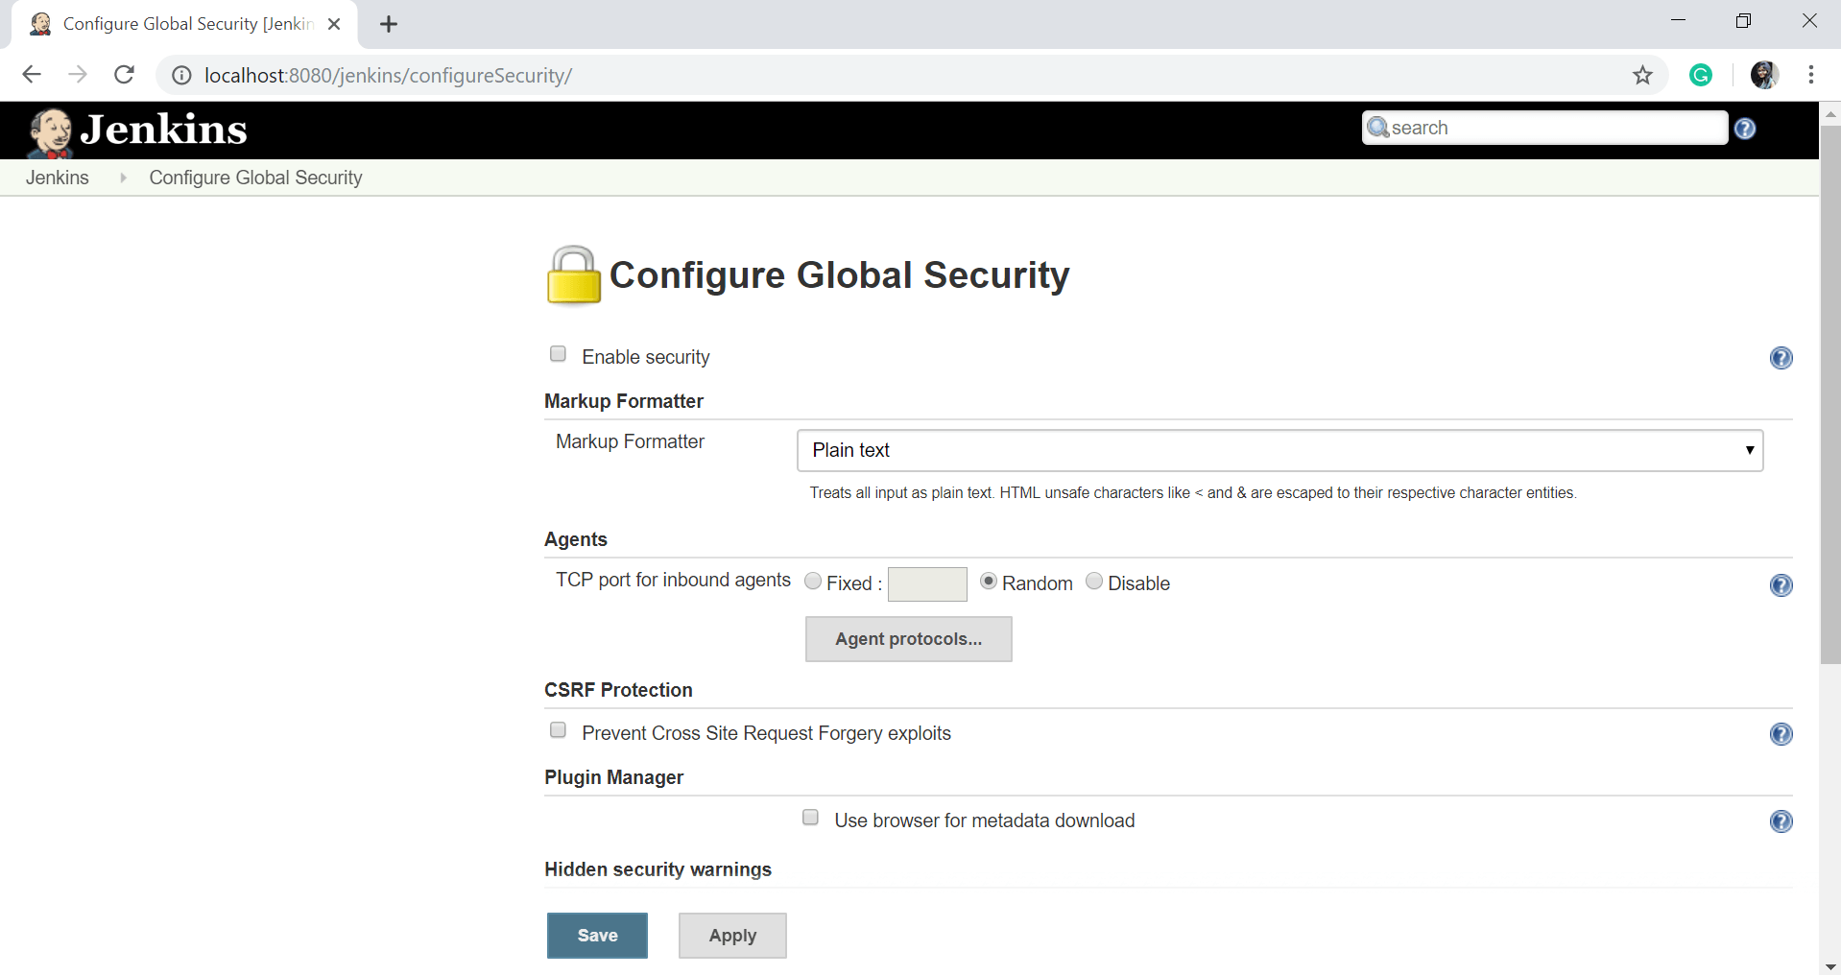

### Reload Configuration from Disk

Jenkins stores all its system and job configuration details as XML files and all XML files are stored in the Jenkins home directory. Jenkins also stores all of the build histories.

If you are moving build jobs from one Jenkins instance to another or archiving old build jobs, you will have to insert or remove the corresponding build job directories to Jenkins's builds directory. You do not have to take Jenkins offline to do this?you can simply use the "Reload Configuration from Disk" option to reload the Jenkins system and build job configurations directly.

### Manage Plugin

Here you can install a wide or different variety of third-party plugins from different Source code management tools such as Git, ClearCase or Mercurial, to code quality and code coverage metrics reporting. We can download, install, update, or remove the plugins from the Manage Plugins screen.

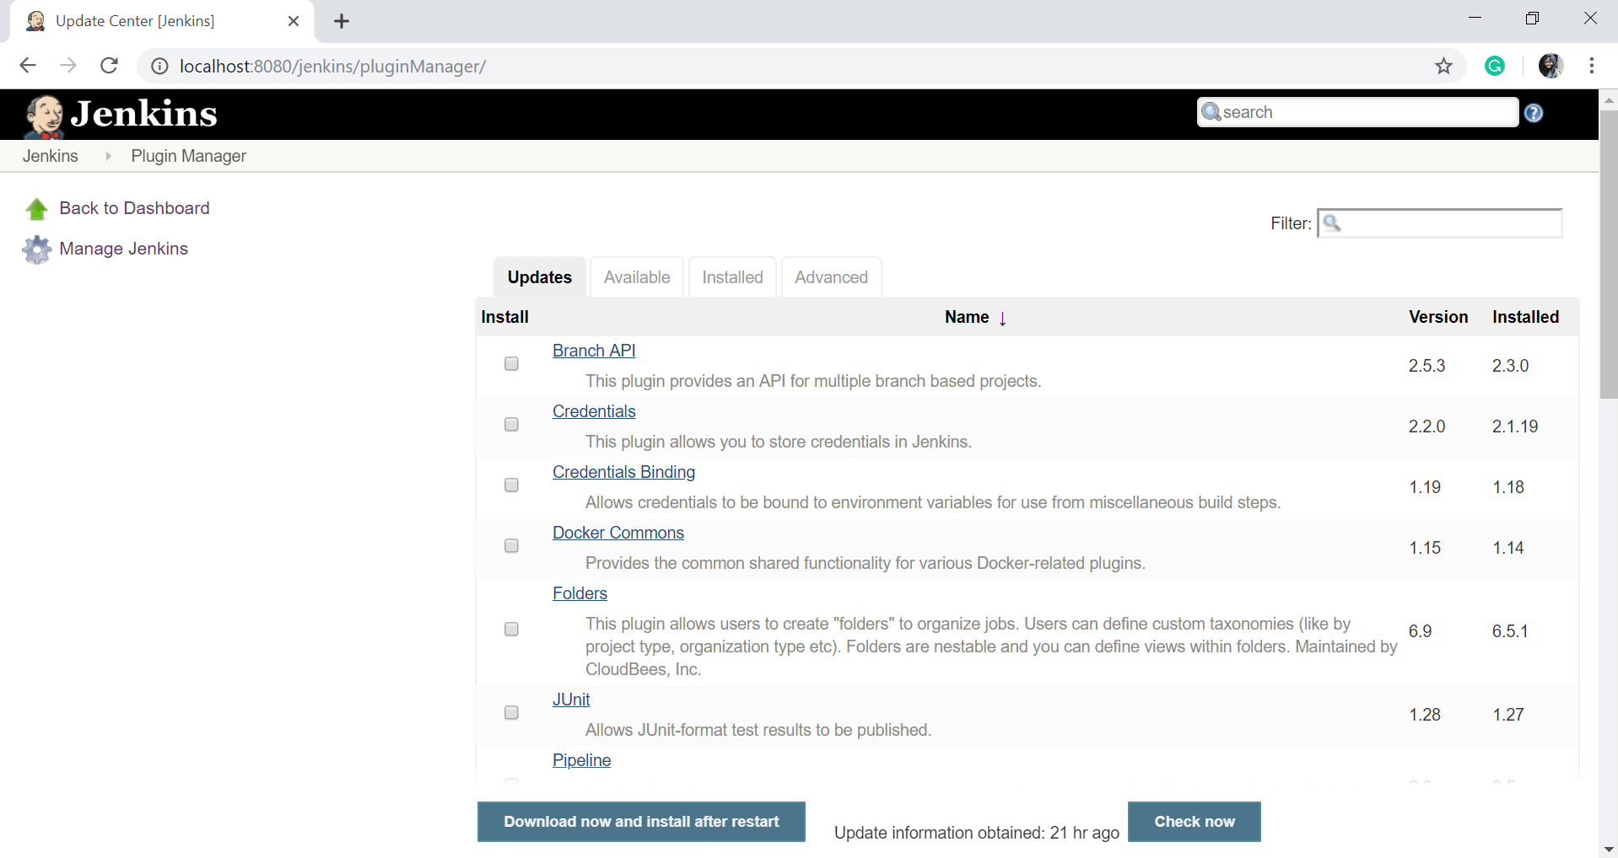

### System Information

This option displays a list of all the current Java system properties and system environment variables. Here you can check what version of Java is currently running in, what user it is running under, and so forth.

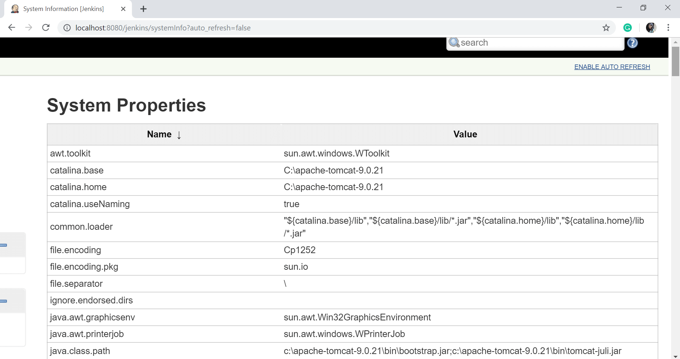

### System Log

The System Log option is used to view the Jenkins log files in real time. As well as, the main use of this option is for troubleshooting.

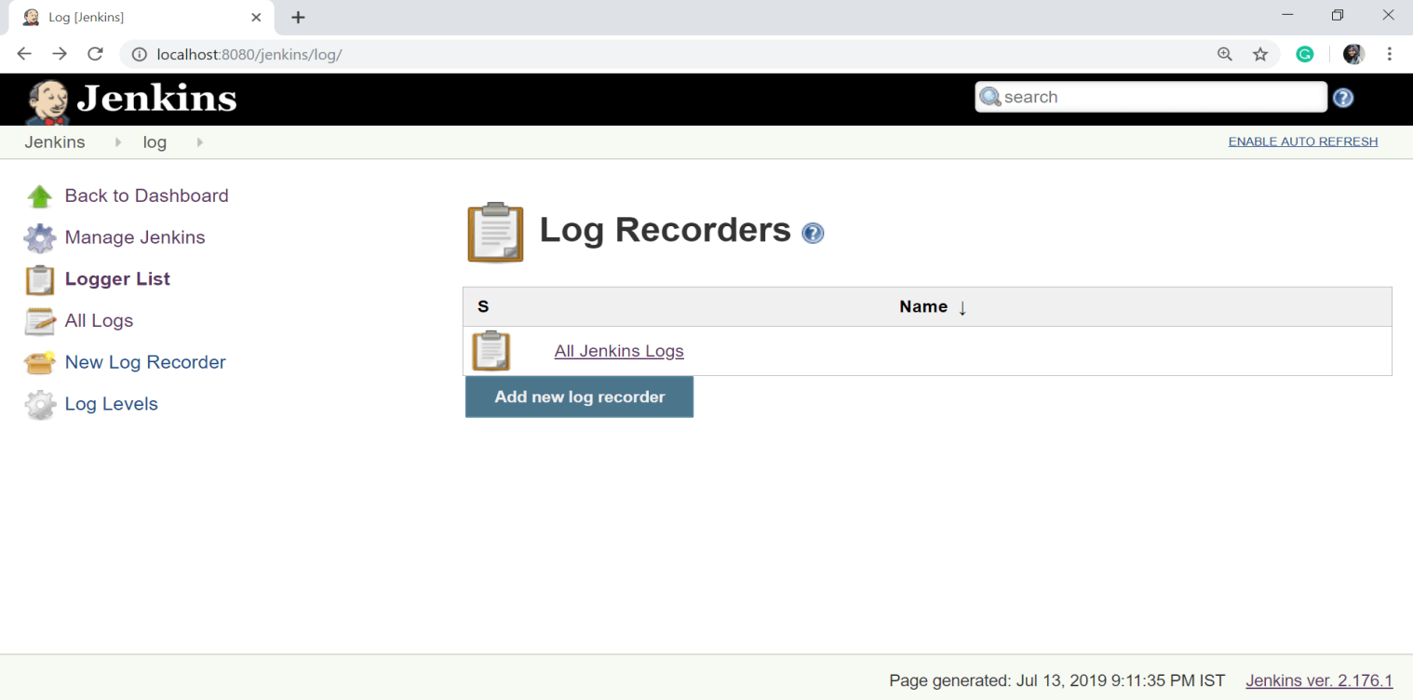

To see the logs click on the 'All Jenkins Logs'.

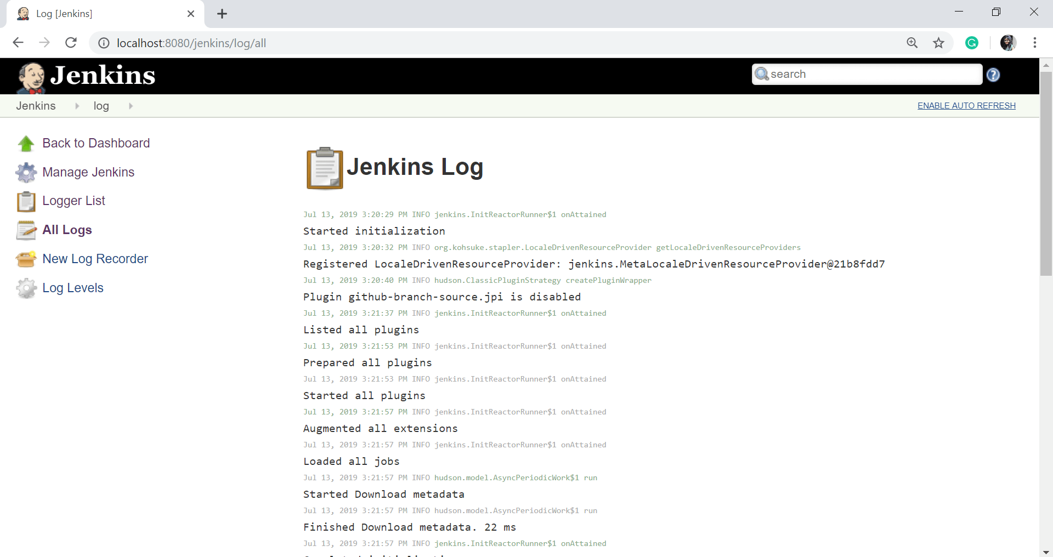

### Load Statistics

This option is used to see the graphical data on how busy the Jenkins instance is in terms of the number of concurrent builds and the length of the build queue which provides an idea of how long your builds need to wait before being executed. These statistics can show you a good idea of whether extra capacity or extra build nodes are required from an infrastructure perspective.

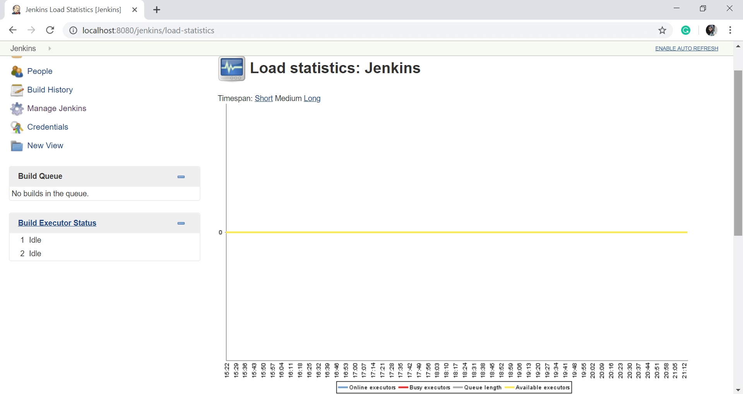

### Jenkins CLI

Using this option, you can access various features in Jenkins through a command-line. To run the Jenkins through cli, first you have to download the Jenkins-cli.jar file and run it on your command prompt as follows:

java -jar jenkins-cli.jar -s http://localhost:8080/jenkins/

This page gives the list of available commands with their description.

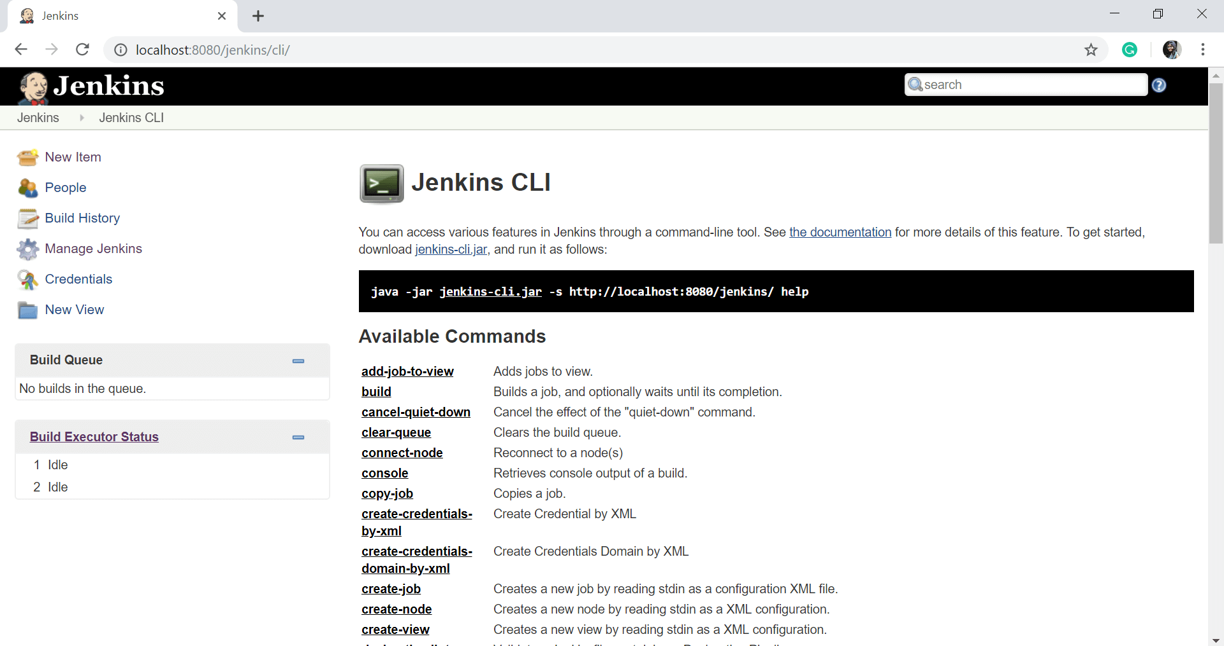

### Script Console

This option allows you to run Groovy scripts on the server. This option is very useful for advanced troubleshooting since it requires a strong knowledge of the internal Jenkins architecture.

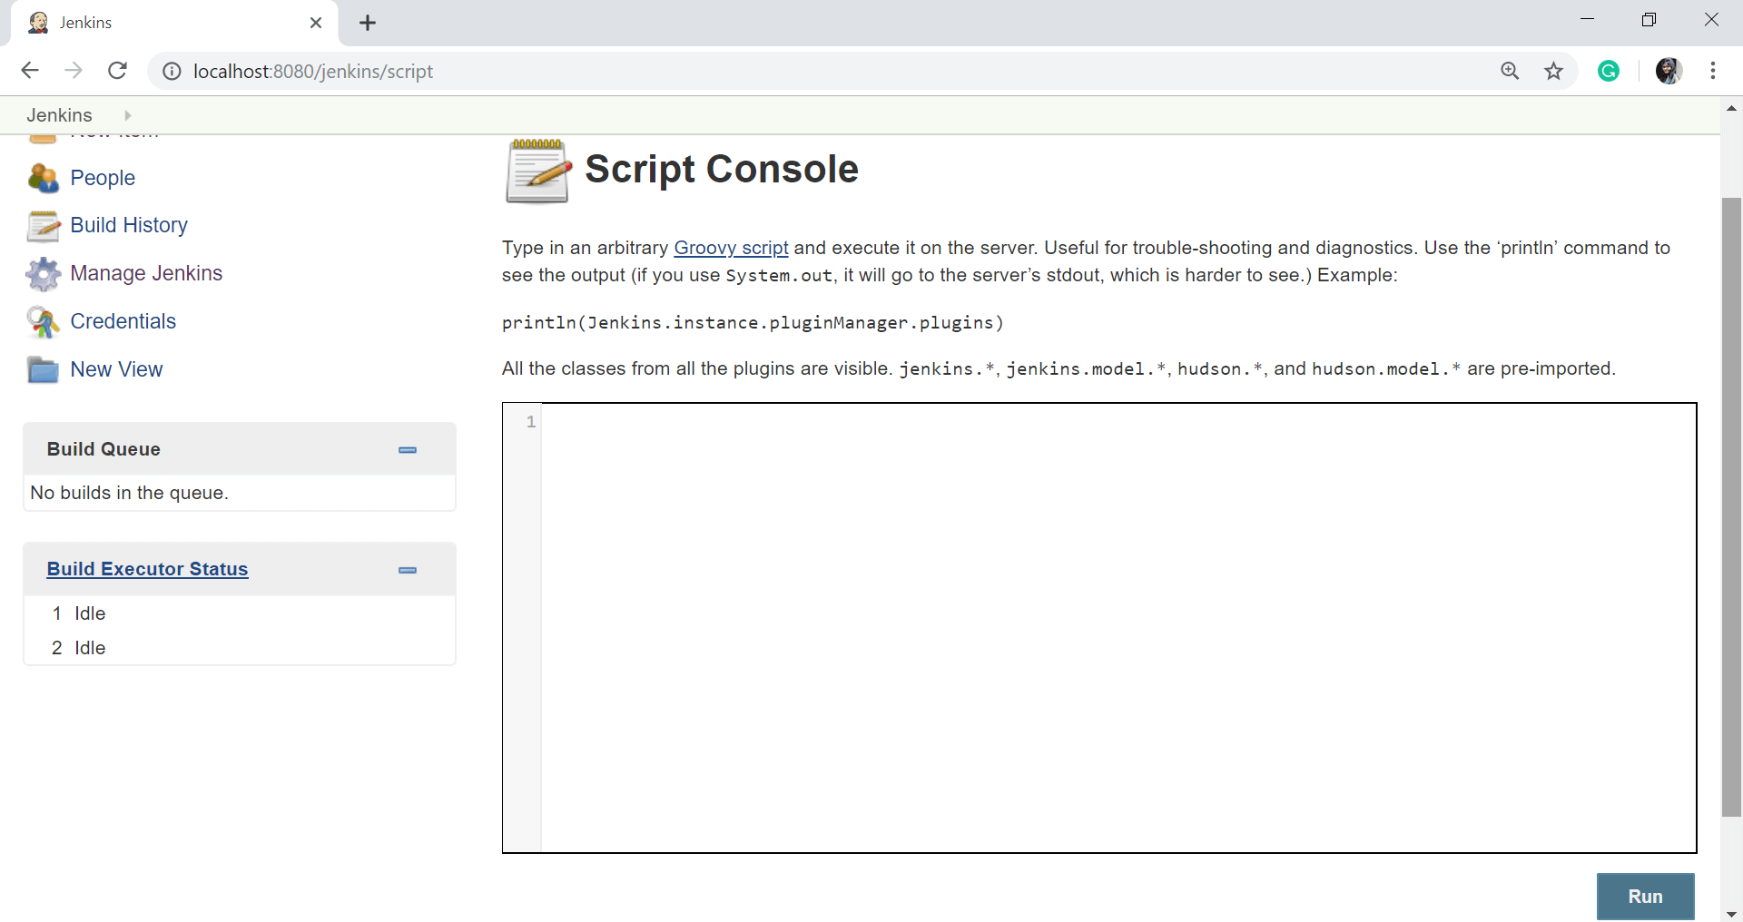

### Manage nodes

Jenkins can handle parallel and distributed builds. In this page, you can configure how many builds you want. Jenkins runs concurrently, and, if you are using distributed builds, set up builds nodes. A build node (slave) is another machine that Jenkins can use to execute its builds.

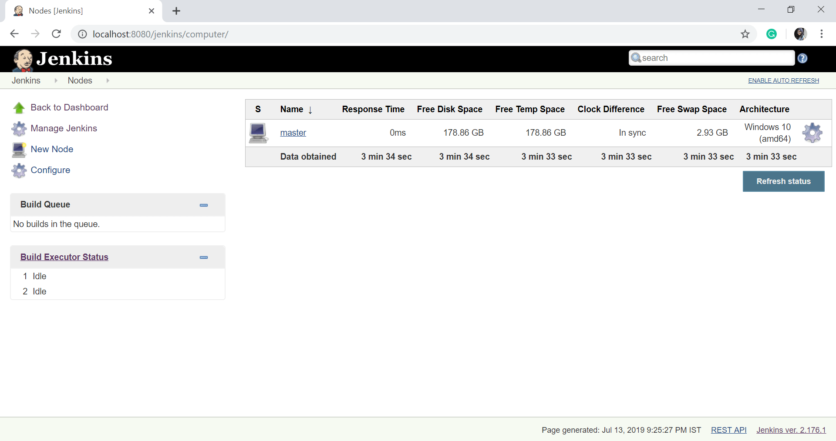

### About Jenkins

This option will show the version and license information of the Jenkins you are running. As well as it displays the list of all third party libraries.

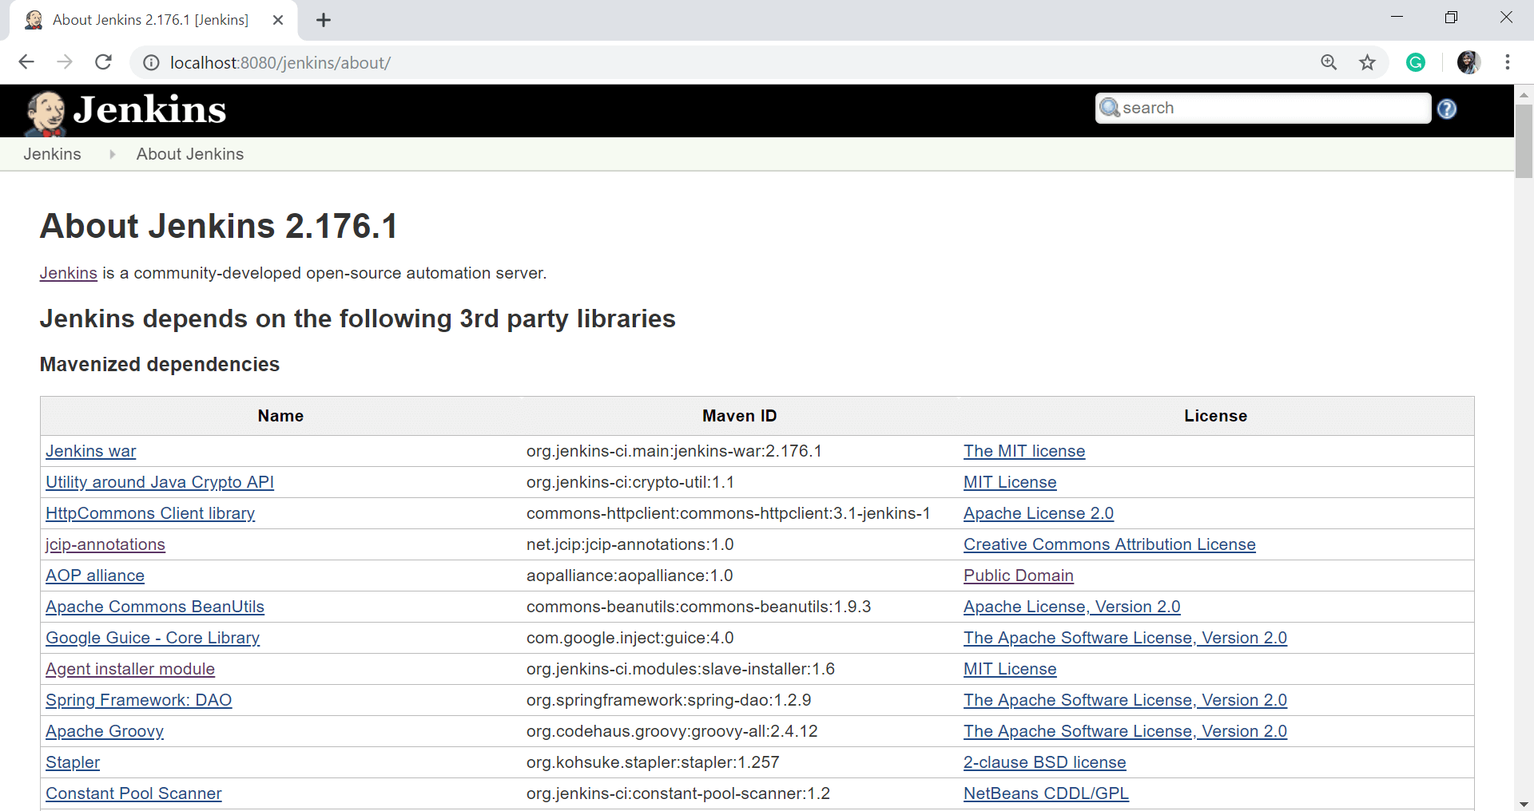

### Prepare for Shutdown

If you want to shut down Jenkins, or the server Jenkins is running on, it is best not to do so when a build is being executed. To shut down Jenkins cleanly, you can use the Prepare for Shutdown link, which prevents any new builds from being started. Eventually, when all of the current builds have completed, you will be able to shut down Jenkins cleanly.

